
Code:
116937E
Update: 20.03.2024
Worker safety instructions
according to §14 GefStoffV

Advice: The samples for risk assessments (Section 6 Hazardous Substance Ordinance/§ 6 GefahrstoffV0) and operating instructions (Section 14 Hazardous Substance Ordinance)/ § 14 GefahrstoffV0) have been created to the best of our knowledge and with the greatest possible care. Ecolab only creates operating instructions for its products on customer request. The operating instructions are based exclusively on the information in the safety data sheet of the product and Ecolab does not guarantee the correctness of the operating instructions for the specific application due to the lack of insight into the individual areas of application of the respective customer. In this respect, our samples can only serve as reference or example for your company. They do not discharge the employer from his responsibility referring to §§ 6 and 14 of the Hazardous Substances Ordinance/§§ 6 and 14 Gefahrstoff-Verordnung and must therefore be adapted by the customer to the local conditions and requirements related to the workplace obligatory. We ask for your understanding that Ecolab cannot be held responsible or accept any liability particularly with regard to the completeness, correctness and applicability of the samples provided.
Company: |  |  |  |  |  | Responsible physician or clinic:
Division: |  |  |  |  |  | Emergency telephone contact:
Position / Function: |  |  |  |  |  | First aid person:
Hazardous Materials Name
Skinman Foam
UFI: 2ENV-X20Q-ED07-PUUW
Biocide - For professional users only.

Components: Aliphatic hydrocarbons,
The following information refer to the handling of undiluted product
Hazards Identification
 | 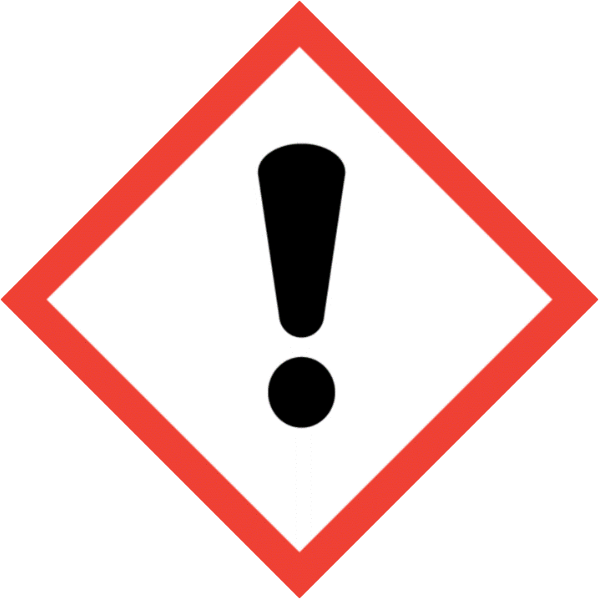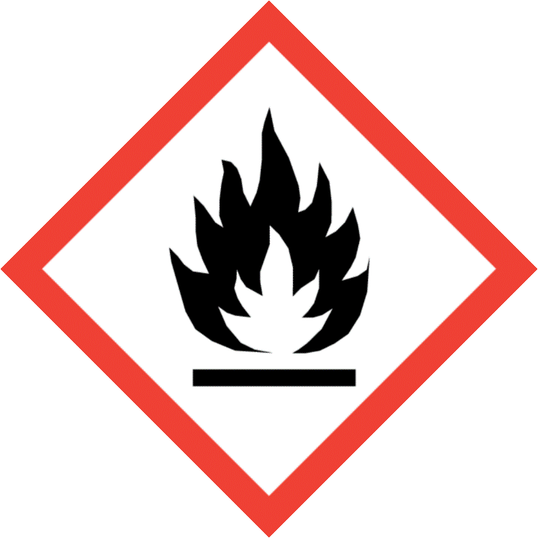
Signal Word |  |  |  | Danger
Hazard Statements |  |  |  | H225 Highly flammable liquid and vapour.  H319 Causes serious eye irritation.  H412 Harmful to aquatic life with long lasting effects.
Hazard class for water |  |  |  | WGK 1
Protection measures and instructions
 |  |  | Avoid contact with skin and eyes.  Use only with adequate ventilation.  Keep away from fire, sparks and heated surfaces.  Take necessary action to avoid static electricity discharge (which might cause ignition of organic vapours).  Wash hands thoroughly after handling.  Open drum carefully as content may be under pressure.  In case of mechanical malfunction, or if in contact with unknown dilution of product, wear full Personal Protective Equipment (PPE).
 |  |  | Eye/face protection: Safety glasses with side-shields
 |  |  | Hand protection: No special protective equipment required.
 |  |  | Skin and body protection: No special protective equipment required.
 |  |  | Respiratory protection: None required if airborne concentrations are maintained below the exposure limit listed in Exposure Limit Information. Use certified respiratory protection equipment meeting EU requirements(89/656/EEC, (EU) 2016/425), or equivalent, when respiratory risks cannot be avoided or sufficiently limited by technical means of collective protection or by measures, methods or procedures of work organization.
Behaviour in danger situations
Suitable extinguishing media: Use extinguishing measures that are appropriate to local circumstances and the surrounding environment.
Unsuitable extinguishing media: High volume water jet
Eliminate all ignition sources if safe to do so., Stop leak if safe to do so., Contain spillage, and then collect with non-combustible absorbent material, (e.g. sand, earth, diatomaceous earth, vermiculite) and place in container for disposal according to local / national regulations (see section 13)., For large spills, dike spilled material or otherwise contain material to ensure runoff does not reach a waterway.Collect spillage.
First aid
In case of eye contact: Rinse immediately with plenty of water, also under the eyelids, for at least 15 minutes. Remove contact lenses, if present and easy to do. Continue rinsing. Get medical attention.
In case of skin contact: Rinse with plenty of water.
If swallowed: Rinse mouth. Get medical attention if symptoms occur.
If inhaledGet medical attention if symptoms occur.
Waste treatment
 |  | Dispose of in accordance with the European Directives on waste and hazardous waste. Waste codes should be assigned by the user, preferably in discussion with the waste disposal authorities.
Date: |  |  |  |  | Signing manager:

